EXPERIMENT 9

VIEWS

**Aim:**

* Create table student with attributes id, name.
* Display
* Create view and select
* Insert values
* Create view with check option
* Insert values and alter table.

**Procedure:**

**Code:**

* **CREATE TABLE stu1(id int, name varchar(50));**
* **INSERT INTO stu1 values(1, 'akhila');**
* **INSERT INTO stu1 values(2, 'buvana');**
* **INSERT INTO stu1 values(3, 'reema');**
* **INSERT INTO stu1 values(4, 'laasya');**
* **INSERT INTO stu1 values(3, 'mansi');**
* **select * from stu1;**

**Output:**

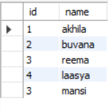

**Code:**

* **create view v_stu1 as select * from stu1 where id = 1;**
* **select * from v_stu1;**

**Output:**

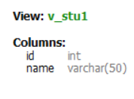



**Code:**

* **insert into v_stu1 values(1, "alekhya");**
* **select * from v_stu1;**

**Output:**

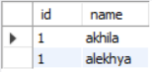

**Code:**

* **alter view v_stu1 as select * from stu1 where id < 5;**
* **insert into v_stu1 values(10, "sally");**
* **select * from v_stu1;**

**Output:**

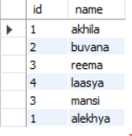

**Code:**

* **alter view v_stu1 as select * from stu1 where id < 5 with check option;**
* **insert into v_stu1 values(11, "sally"); #will not happen as it is not satisfying the where condition (As we used check option)**

**Output:**





**Code:**

* **insert into v_stu1 values(2, "sally");**

**Output:**

